

**YAŞAR UNIVERSITY**

**FACULTY OF ENGINEERING**

**PROJECT CHARTER**

**Project Management**

**PATIENT HEALTH MONITORING**

**Section Number:2**

**Group Number: J**

**Members:**

**ELİF ÖZEN**

**GÖZDE KABAK**

**ŞEVVAL TEKKOL**

**BERİL BALTACI**

**MEHMET KARAKÖSE**

**Lecturer**

**Halil POSACI**

**İzmir, 2018**

**PROJECT PURPOSE**

This project is an online system where people can monitor heart health information. The main objective of the project is to develop a competitive online system for monitoring heart health. Within the scope of the project, people can use a device that they can use without restricting their daily movements and it provides their integration with mobile devices. The hardware part can operate lightly anywhere and communicate wirelessly. Health information will be shared with patients and doctors through web and mobile applications to be developed. The benefits of our project will play a major role in early diagnosis of long-term heart information to be provided to doctors. The hardware implementation will have made by a team from Electrical and Electronics Engineering department. Due to the fact that the systems currently used are cumbersome, unmovable and difficult to use, the new system we will design will be preferred in the market due to their ease of use and usability. Also, a good service will be offered to users via web and mobile software.

**OBJECTIVE**

* It is planned to profit by reducing the sales prices in the market and showing the easy accessibility to the user.
* We aim to terminate the testing process of the prototype produced within 1 year and to obtain a sales share of at least 10% profit based on the sales prices in the market.
* After the sale of the prototypes, we want to follow the development stages of the product and stay in contact with the company.
* We plan to donate a certain amount of produced devices to hospitals to be given to patients with poor economic conditions.

**SCHEDULES**

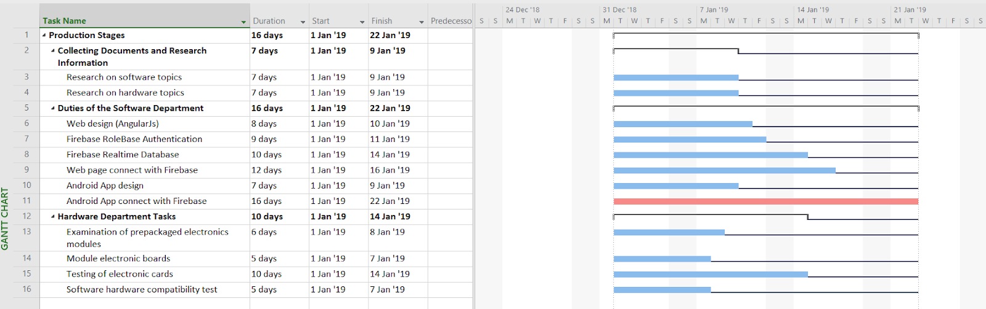

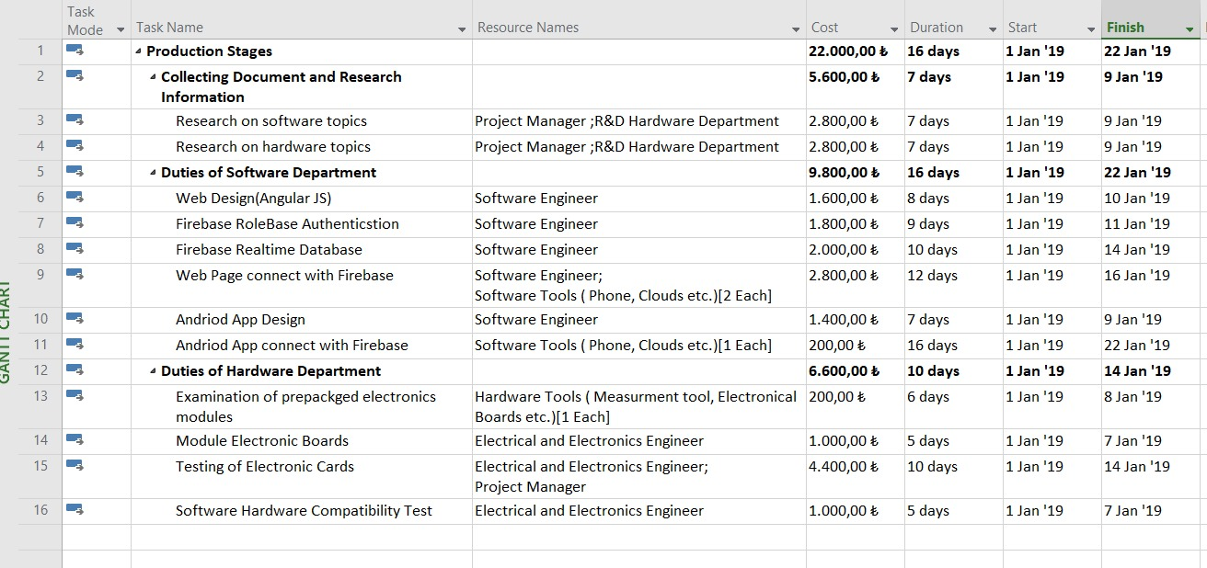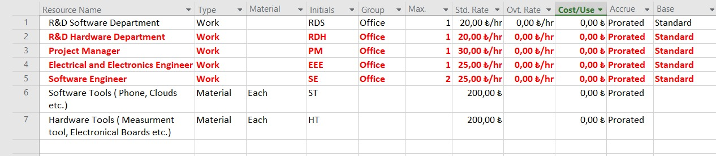**RESOURCES**

**STAKEHOLDERS**

|  |  |  |
| --- | --- | --- |
| STAKEHOLDERS’ NAME | ROLES OF STAKEHOLDER | DESCRIPTION OF TASK |
| Tubitak BIGG | **Investor** | **BIGG is the investor competition that we can apply within the scope of the project.** |
| KOSGEB | **Investor** | **KOSGEB invests grants to young entrepreneurs to realize their ideas.** |
| Mehmet KARAKÖSE | **Founder** | **Founder is manage finance support and project timeline.** |
| Elif Özen | **Project Manager** | **The product takes full responsibility for the worklist when running to the destination.** |
| Gözde Kabak | **Electrical and Electronics Engineer** | **Engineers develop the electrical circuit.** |
| Beril BALTACI  Şevval TEKKOL | **Software Engineer** | **Software Engineers are responsible for the development of the software in the project.** |

**RISK MANAGEMENT PLANS**

|  |  |  |  |
| --- | --- | --- | --- |
| **Risk Section of The Project** | **Probability of Risk** | **Impact of Risk** | **Definition of Risk** |
| **Schedules** | **\*\*\*** | **\*\*** | **Failure to comply with the plan because employees are sick or work is longer than expected due to technical failures.** |
| **Duties of the Software Department** | **\*\*\*\*** | **\*\*\*** | **Update problems to be experienced at the application level cause interruption of the system.** |
| **Duties of the Software Department** | **\*\*** | **\*\*\*\*\*** | **Loss of data due to insufficient data backup of system data** |
| **Tasks of the Hardware Department** | **\*\*\*\*** | **\*\*** | **Loss of time and material due to faulty or faulty electronic cards.** |
| **Tasks of the Hardware Department** | **\*** | **\*\*\*\*** | **Revision of electronic cards due to hardware and software incompatibility within a certain period of time during testing.** |
| **Tasks of the Hardware Department** | **\*\*\*\*\*** | **\*\*** | **The cargo does not reach the expected time** |

In the above table, some risks and probabilities of these risks are given. The importance to be taken for the solution of these risks can be listed as follows;

1) Time Management will be used for the efficient use of time during the construction of the project. Pessimistic and optimistic deadlines for the project will be determined and the time management for the project will be carried out successfully. If necessary, the working hours will be rearranged.

2) In order to prevent the risks arising from the materials to be used in the project, more than one supplier will be contacted and more than one option will be available for the same element.

3) Quality Management will be used to ensure the quality standards of the equipment to be purchased and the devices to be produced. With the cost calculations to be updated, it will be aimed to get better quality equipments and to increase the production quality.

4) Resource Management will be used to solve the resources and financial problems that may be encountered during the project. The necessary situations will be searched for new sources and sponsors.

**EVALUATION METHODS**

BAC - Budget in Completion

EAC - Estimated cost on completion date

ETC - Estimated Cost Completed

AC - Real Cost Now (measure time)

PV - Planned Value for Currently

EV - Earned Value now

AT - Current Time

ST - Time to complete work

Cost Variance CV = EV – AC

Program Variance SV = EV- PV

Time Variance TV = ST - AT

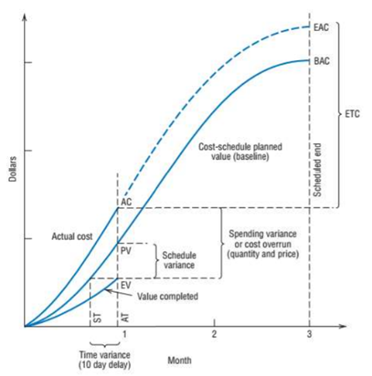 When the variables are defined as above, the ratios to be used to control the continuity of the project and to improve the project are as follows:

* Cost Performance Index CPI = EV / AC
* Timing Performance Index SPI = EV / PV
* Time Performance Index TPI = ST / AT
* Cost Timing Index CSI = CPI * SPI = / AC * PV